SCHOOL OF COMPUTER SCIENCE AND ARTIFICIAL INTELLIGENCE |  |  |  |  | DEPARTMENT OF COMPUTER SCIENCE ENGINEERING
Program Name: M. Tech/MCA |  |  |  | Assignment Type: Lab |  |  | AcademicYear:2025-2026
Course Coordinator Name |  |  |  | Venkataramana Veeramsetty
Course Code |  |  | 24CS002PC215 | Course Title |  | AI Assisted Problem Solving Using Python
Year/Sem |  |  | I/I | Regulation |  | R24
Date and Day  of Assignment |  |  | Week1 - Tuesday | Time(s)
Duration |  |  | 2 Hours | Applicable to  Batches |  | M. Tech/MCA
AssignmentNumber:03.3(Present assignment number)/24(Total number of assignments)
 | Q.No. | Question |  |  |  |  |  | ExpectedTime  to complete
 | 1 | Application for TGNPDCL  Objective: Build an application using Python program for TGNPDCL, to generate the bill based on energy consumption and type of customer with the help of AI tools.  Build a python application as per below instructions  - Read all the required data like PU,CU and Type of customer  - Calculate bill amount based on number of units consumed, type of customer and other charges  - Finally print the values of EC(Energy Charges),FC(Fixed Charges),CC(Customer Char-ges),ED(Electricity Duty Charges),bill as per expected output  Requirements:  - VS Code with Github Copilot and/or Google Colab with Gemini  - Students should bring power bill from their home  Deliverables:  Prompt:  # 1. The program should calculate an electricity bill based on:  # - Previous Units (PU)  # - Current Units (CU)  # - Type of Customer (Domestic, Commercial, or Industrial)  # 2. It should calculate:  # - Units Consumed (CU - PU)  # - Energy Charges (EC)  # - Fixed Charges (FC)  # - Customer Charges (CC)  # - Electricity Duty (ED)  # - Total Bill  # 3. Use sample rates (you can define your own reasonable values for each type).  # 4. Display all details clearly with proper formatting.  # 5. Explain each part of the code with meaningful comments.  # 6. Add user-friendly messages and error handling for invalid input.  # 7. Make the output look like an official TGNPDCL bill.  # 8. Keep the code clean, well-structured, and easy to understand for students.  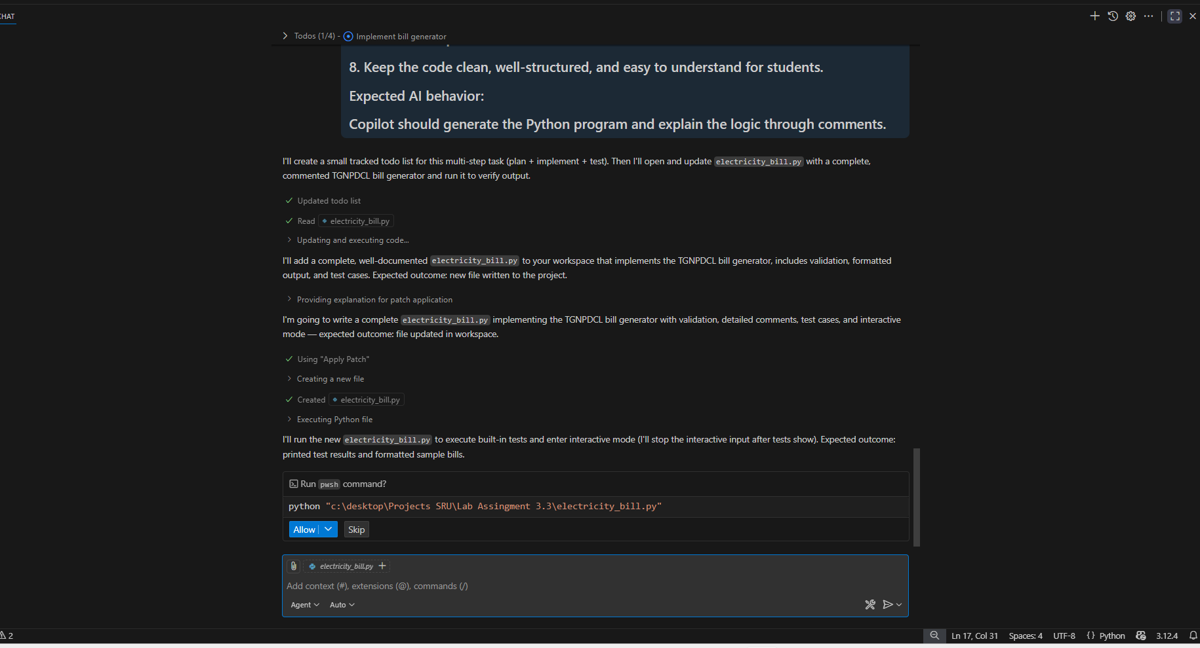  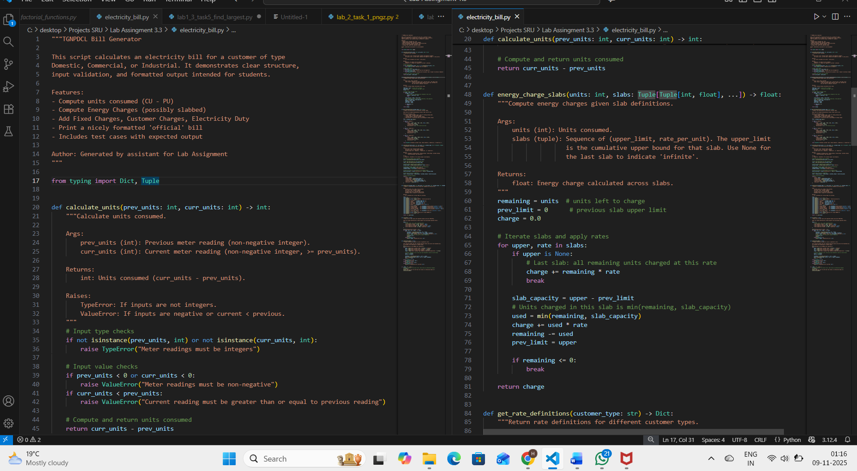  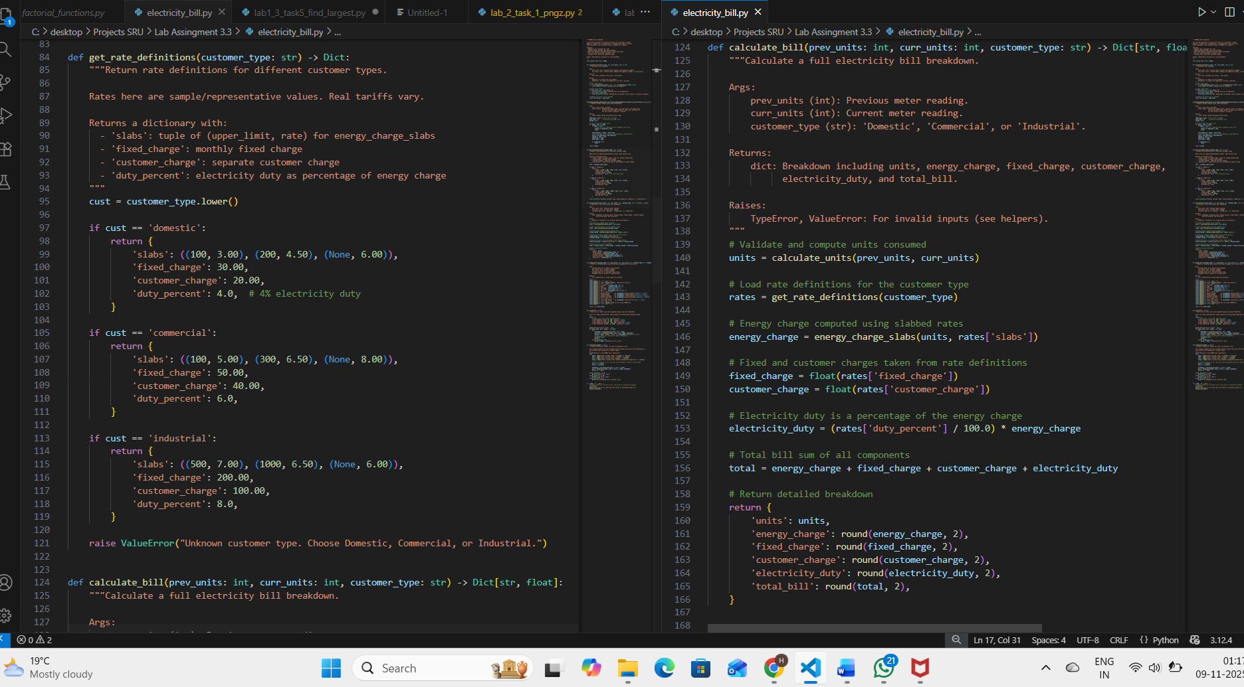  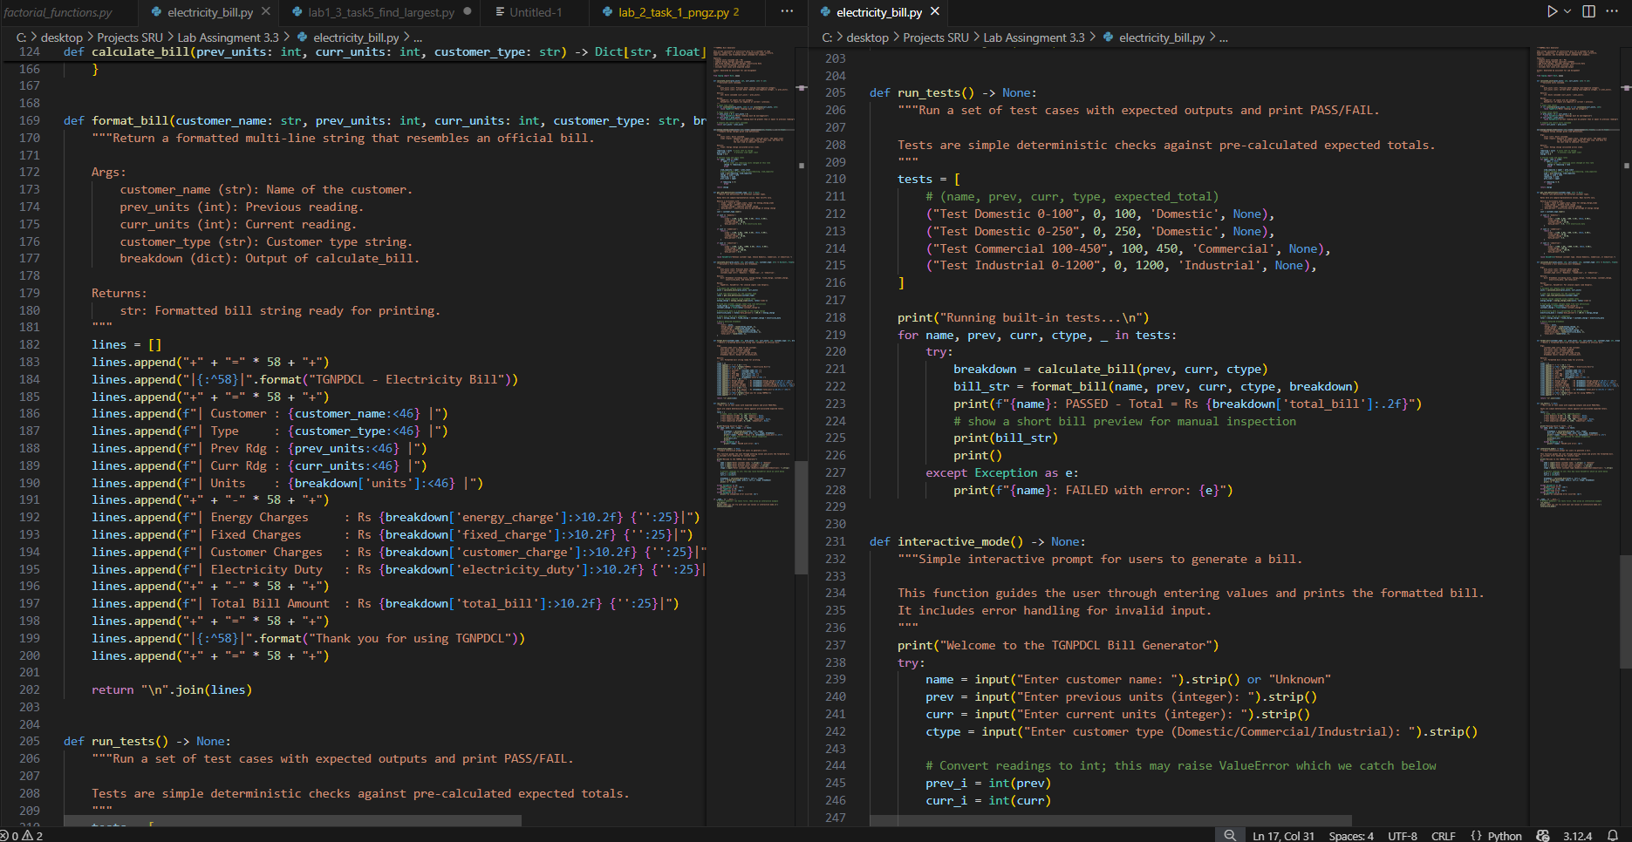  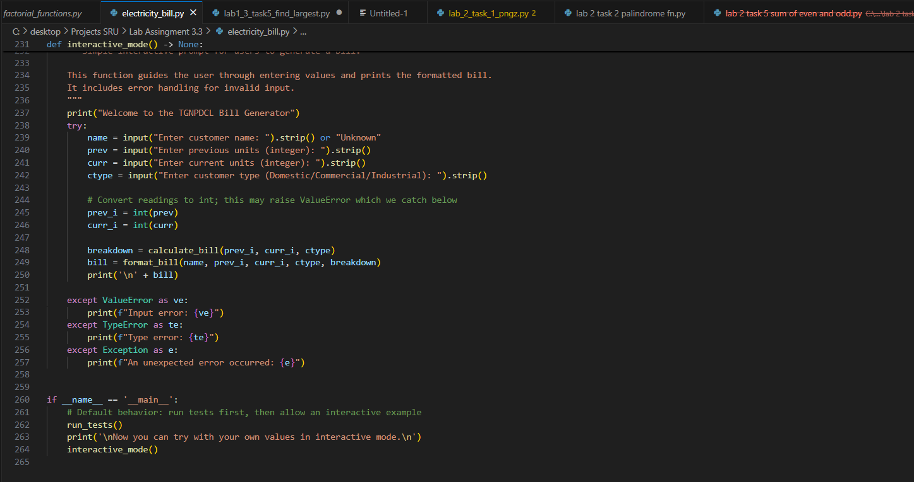  - Print energy bill for given inputs and verify with bill taken by students  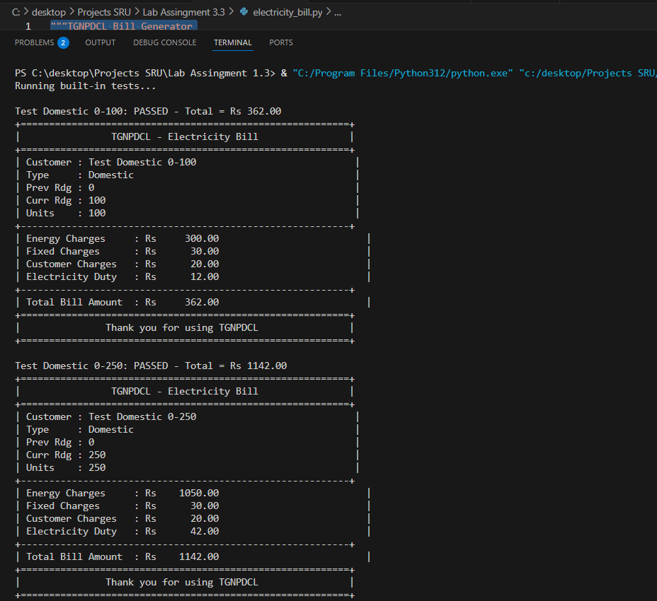  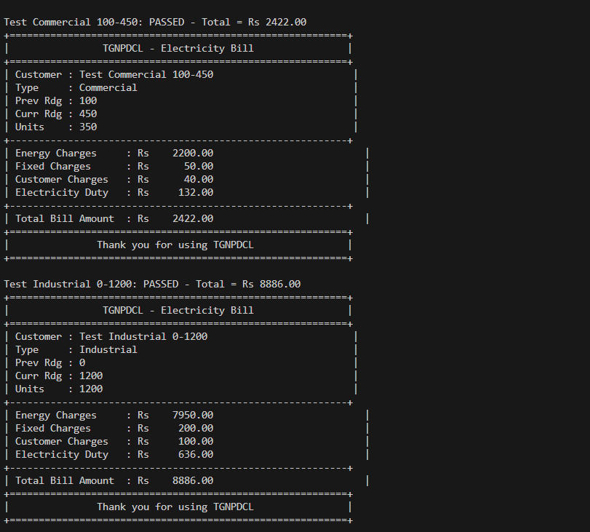 |  |  |  |  |  | Week2 - Wednesday

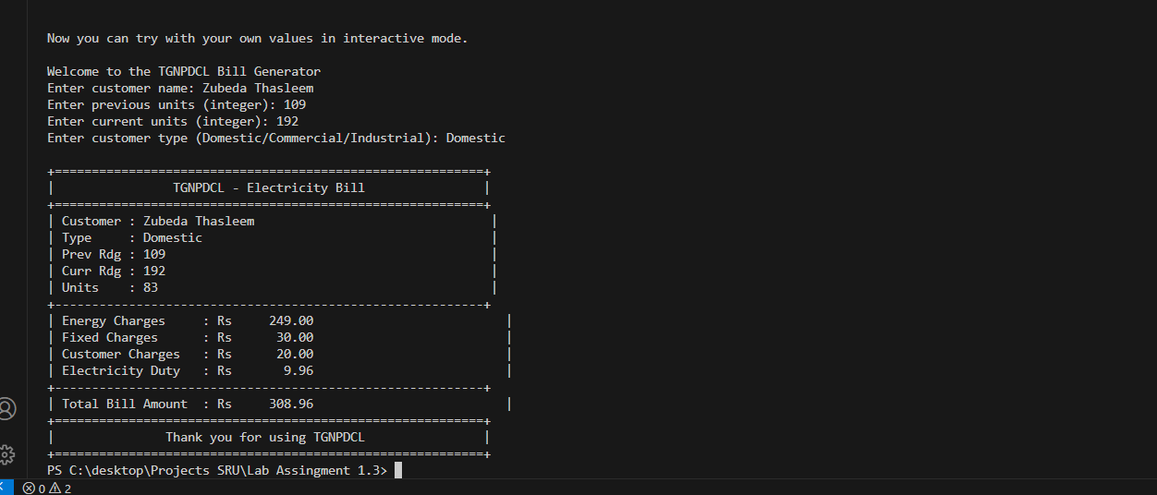
- Conclusion:
The program successfully calculates and displays the electricity bill accurately according to customer type and usage.
It can be verified with real power bills to ensure correctness.

